AWS assessment
Question 1
Step 1: Create an EC2 instance in N. Virginia region.
Step 2: Using key pair SSH into the launched instance.
ssh -i <keyname>.pem ubuntu@ec2-3-83-228-73.compute-1.amazonaws.com
Step 3: Install Apache server after remote access into the EC2 instance.
Sudo apt-get install apache2
Step 4: Add an index.html file to apache server
Step 5: browse the DNS adddress of the instance and we will be able to see the index.html page.
Step 6: create a snapshot of this instance and copy it in another region (Ohio).
Step 7: Create image of this instance in another region (Ohio).
Step 8: Launch the image created in another region (Ohio).
Step 9: Run the instance.

Region: N. Verginia
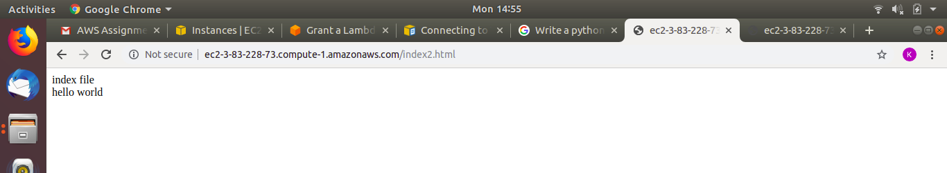
Region: Ohio
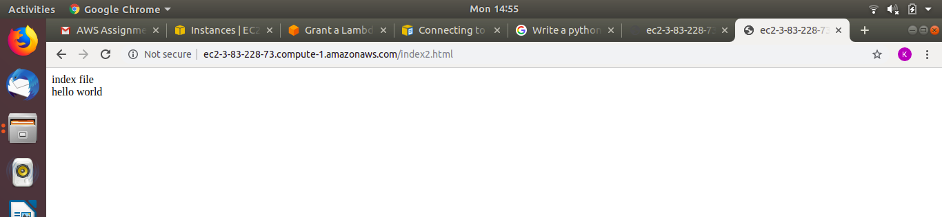

Question 2
import sys
import logging
import boto3
s3 = boto3.resource('s3')
bucketName = sys.argv[1]
key = sys.argv[2]
logging.debug(bucketName)
logging.debug(key)
bucket = s3.Bucket(bucketName)
versions = list(bucket.object_versions.filter(Prefix=key).all())
VersionId = versions[1].get().get('VersionId')
bucket.download_file(key, key, ExtraArgs={'VersionId' : VersionId})

Question 3
Bucket Policy
{
"Id": "Policy1563189922475",
"Version": "2012-10-17",
"Statement": [
{
"Sid": "Stmt1563189673149",
"Action": [
"s3:GetObject"
],
"Effect": "Deny",
"Resource": "arn:aws:s3:::krutikape/files/*",
"Principal": "*"
},
{
"Sid": "Stmt1563189720341",
"Action": [
"s3:GetObject"
],
"Effect": "Allow",
"Resource": "arn:aws:s3:::krutikape/*",
"Principal": "*"
},
{
"Sid": "Stmt1563189902268",
"Action": [
"s3:DeleteObject",
"s3:PutObject"
],
"Effect": "Allow",
"Resource": "arn:aws:s3:::krutikape/*",
"Principal": {
"AWS": [
"arn:aws:iam::488599217855:root"
]
}
}
]
}

Question 4
import json
def lambda_handler(event, context):
return {
'statusCode': 200,
'body': event['name']
}

mapping template:
#set($inputRoot=$input.path(‘$’))
{
“name”: “$input.params(‘name’)”
}

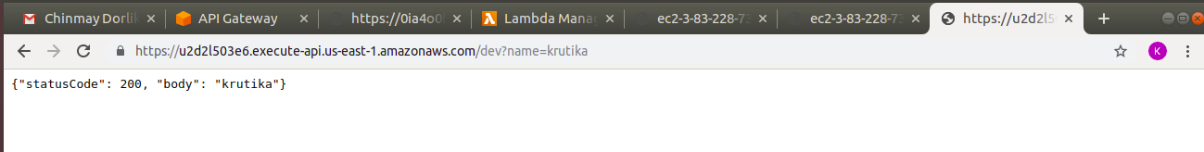

Question 5
import json
import os
import boto3
import logging

logging.basicConfig(format='{asctime}.{msecs:03.0f} {filename}:{lineno} {levelname} {message}', style='{',datefmt='%Y-%m-%d %H:%M:%S')

def lambda_handler(event, context):

s3 = boto3.resource('s3')
logging.debug(event)

# Name of destination bucket
destinationBucket = s3.Bucket(os.environ['destbucket'])

key = event['Records'][0]['s3']['object']['key'] #read object key
source_bucket = record['s3']['bucket']['name'], # Source bucket name
if source_bucket == destinationBucket: #if source and destination bucket are equal raise an exception
raise Exception("RECURSION ALERT")
copy_source = {
'Bucket': source_bucket,
'Key': key
}
obj = destinationBucket.Object(key)
obj.copy(copy_source) #copy the file from source to destination

return {
'statusCode': 200,
}

Question 6
Step 1: In EC2 service go to load balancer
Step 2: create load balancer. Choose application load balancer.
Step 3: Type name, select vpc and select two subnets
Step 4: click next
Step 5: select existing security group
Step 6: click next
Step 7: Select new Target Group
Step 7: Select Target Type as IP
step 8: click next
Step 9: Add the private ip address of an instance
step 10: click next and create

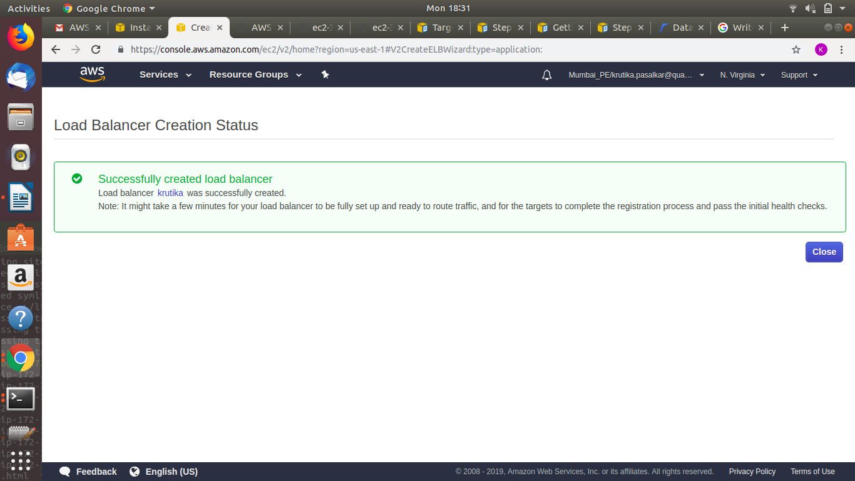

Question 7
1. In EC2, select launch configuration
2. create launch configuration
3. select amazon linux 2
4. In advanced details, add the apache server script in user data.
5. In configure security group, add http and https
6. click next and launch the configuration.
7. select create auto scaling group
8. add vpc and subnets
9. In configure scaling policies, scale between 1 to 5
10. click launch
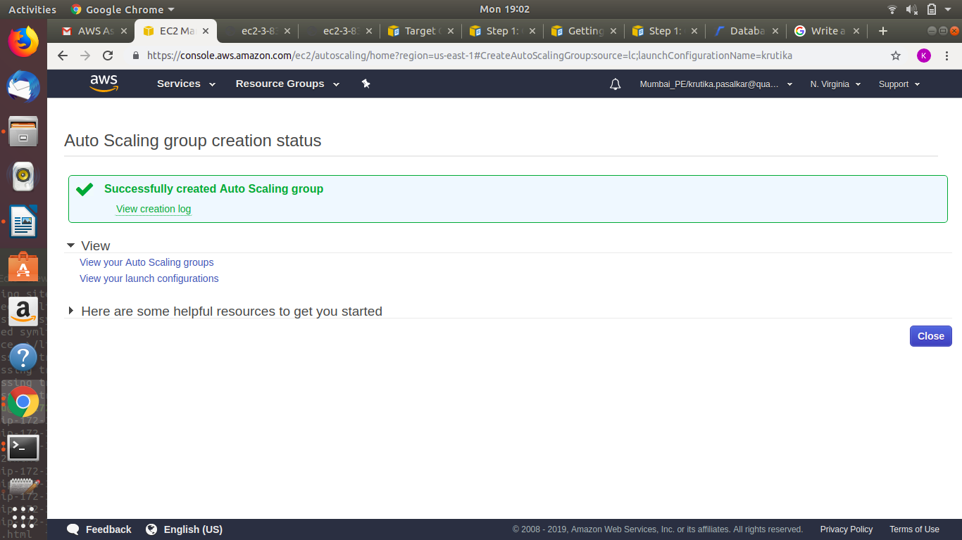

Question 8
import pymysql
import sys

connection = pymysql.connect(
host='yrdbinstance.csaruqlxxway.us-east-1.rds.amazonaws.com',
user=sys.argv[1],
password=sys.argv[2],
db='yrdb',
)
my_database = connection.cursor()
sql_statement = "INSERT INTO games (gid,gname,publisher,rating) values(%s,%s,%s,%s)"
values = ("4","CS:GO","steam","9")
#my_database.execute(sql_statement,values)
connection.commit()

sql_statement = "SELECT * FROM games"
my_database.execute(sql_statement)
output = my_database.fetchall()
for x in output:
print(x)

sql_statement = "UPDATE games SET gname='FIFA19' where gid='2'"
my_database.execute(sql_statement)
connection.commit()

sql_query = "DELETE FROM games where gname='cricket07'"
my_database.execute(sql_query)
connection.commit()
print("Row(s) deleted successfully!!!!")

Question 9
import boto3
import time

def create_games_table(dynamodb_client):
try:
dt_response = dynamodb_client.describe_table(TableName='Games_krutika')
print("Table already exists")
except dynamodb_client.exceptions.ResourceNotFoundException:
tags_list = [
{'Key': "Email", 'Value': "krutika.pasalkar@quantiphi.com"},
{'Key': "Location", 'Value': "Mumbai"},
{'Key': "Name", 'Value': "krutika"},
{'Key': "Project", 'Value': "Mumbai_PE"},
{'Key': "office-time", 'Value': "Mumbai-14"}
]
dynamodb_client.create_table(
AttributeDefinitions=[
{
'AttributeName': 'gid',
'AttributeType': 'N'
},
{
'AttributeName': 'gname',
'AttributeType': 'S'
},
{
'AttributeName': 'rating',
'AttributeType': 'N'
},
],
TableName='Games_krutika',
KeySchema=[
{
'AttributeName': 'gid',
'KeyType': 'HASH'
},
{
'AttributeName': 'gname',
'KeyType': 'RANGE'
},
],
LocalSecondaryIndexes=[
{
'IndexName': 'gid_rating_index',
'KeySchema': [
{
'AttributeName': 'gid',
'KeyType': 'HASH'
},
{
'AttributeName': 'rating',
'KeyType': 'RANGE'
},
],
'Projection': {
'ProjectionType': 'KEYS_ONLY'
},
},
],
BillingMode='PROVISIONED',
ProvisionedThroughput={
'ReadCapacityUnits': 5,
'WriteCapacityUnits': 5
},
Tags=tags_list
)
while True:
dt_response = dynamodb_client.describe_table(TableName='Games_krutika')
if dt_response['Table']['TableStatus'] != 'ACTIVE':
print("Waiting for table creation...")
time.sleep(5)
else:
break

def add_items(dynamodb_client):
response1 = dynamodb_client.put_item(
TableName='Games_krutika',
Item={
'gid': {
'N': "1",
},
'gname': {
'S': "Game 1a",
},
'publisher': {
'S': "pa",
},
'rating': {
'N': "3",
},
'release_date': {
'S': "2019/01/01",
},
'genres': {
'SS': ['ga', 'gb'],
}
}
)
response2 = dynamodb_client.put_item(
TableName='Games_krutika',
Item={
'gid': {
'N': "1",
},
'gname': {
'S': "Game 1b",
},
'publisher': {
'S': "pa",
},
'rating': {
'N': "4",
},
'release_date': {
'S': "2019/01/02",
},
'genres': {
'SS': ['gc', 'gb'],
}
}
)
response3 = dynamodb_client.put_item(
TableName='Games_krutika',
Item={
'gid': {
'N': "2",
},
'gname': {
'S': "Game 2a",
},
'publisher': {
'S': "pb",
},
'rating': {
'N': "2",
},
'release_date': {
'S': "2019/01/03",
},
'genres': {
'SS': ['gd'],
}
}
)
response4 = dynamodb_client.put_item(
TableName='Games_krutika',
Item={
'gid': {
'N': "2",
},
'gname': {
'S': "Game 2b",
},
'publisher': {
'S': "pc",
},
'rating': {
'N': "5",
},
'release_date': {
'S': "2019/01/04",
},
'genres': {
'SS': ['gc', 'gb', 'gd'],
}
}
)
print("Added items to table")

if __name__ == '__main__':
dynamodb_client = boto3.client('dynamodb', region_name='us-east-1')
create_games_table(dynamodb_client)
add_items(dynamodb_client)

Question 10
import boto3
from boto3.dynamodb.conditions import Key

def make_query():
dynamodb = boto3.resource('dynamodb', region_name='us-east-1')
table = dynamodb.Table('Games_krutika')
gid = 2
query_response = table.query(
IndexName='gid_rating_index',
Select='ALL_PROJECTED_ATTRIBUTES',
KeyConditionExpression=Key('gid').eq(gid)
)
for item in query_response['Items']:
print("gname: {}, rating: {}".format(item['gname'], item['rating']))

if __name__ == '__main__':
make_query()

